AZAMOR 2014 – “fact sheet“
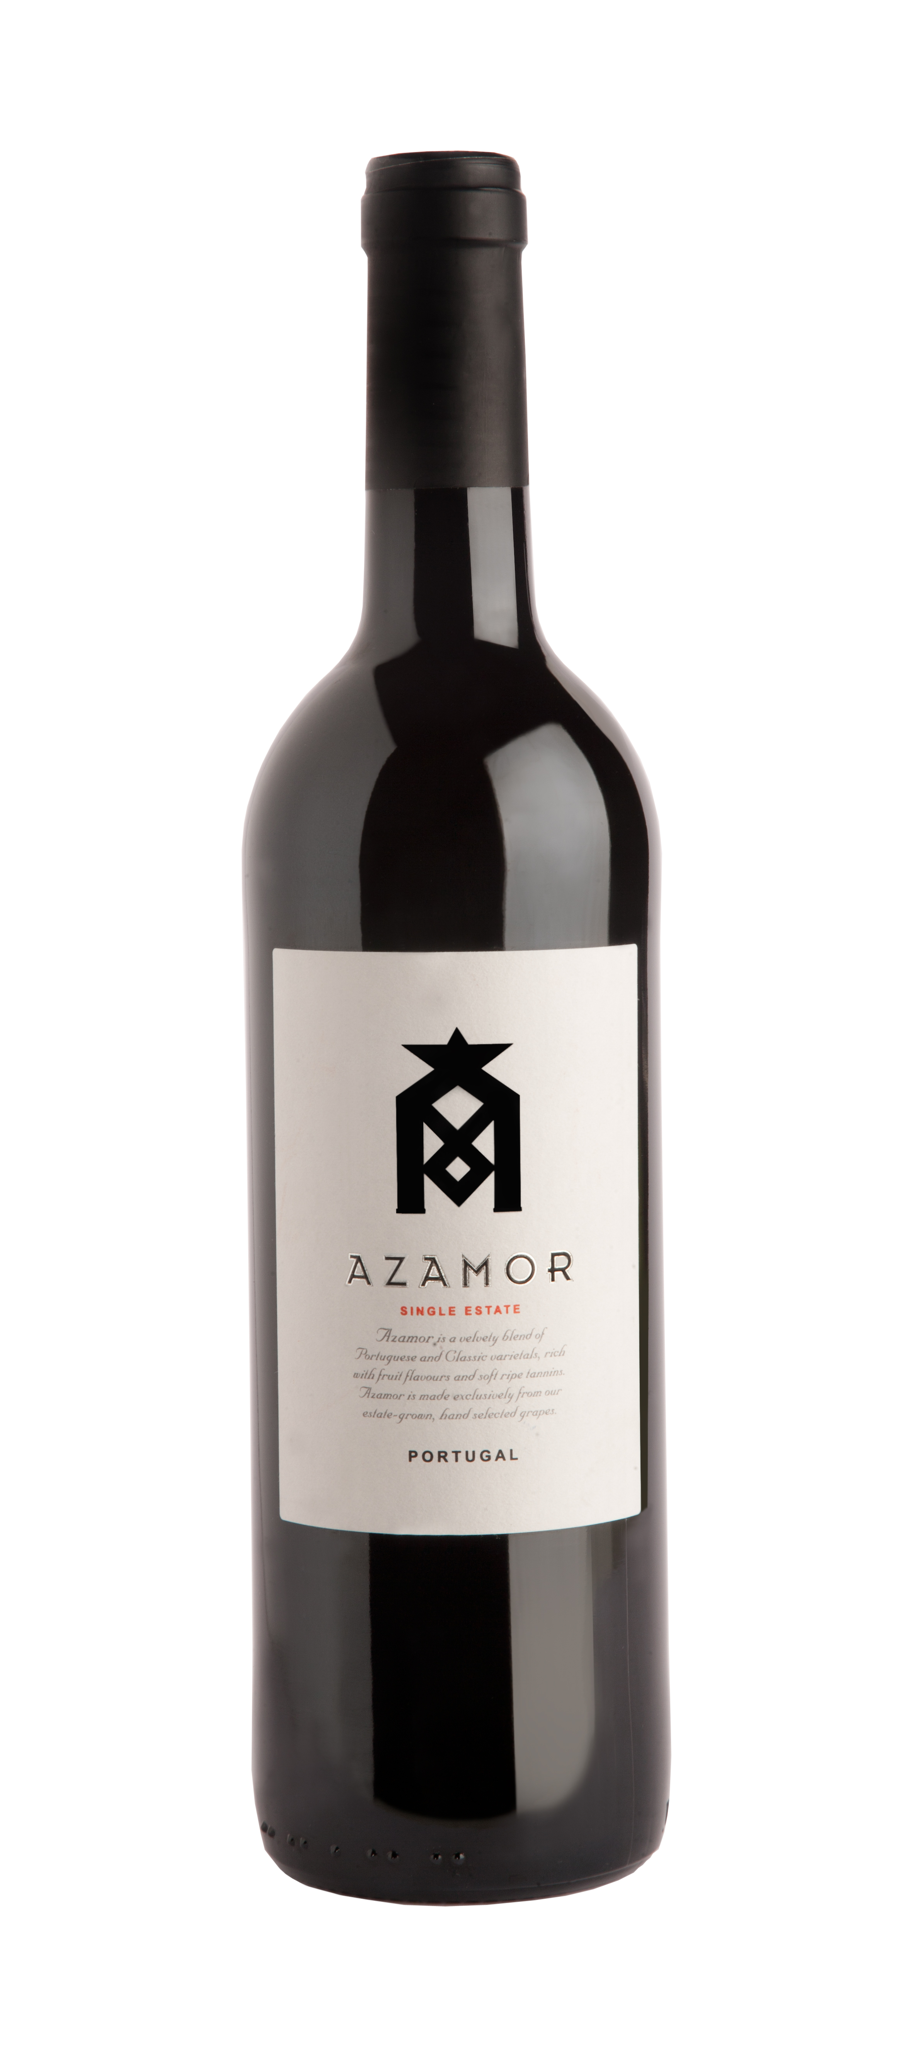

AZAMOR 2014 is a specially crafted blend of classic French and Portuguese grape varieties. Each selected parcel of fruit is fermented and matured separately with the final blend created just prior to bottling.

Tasting notes

AZAMOR 2014 with is beautifully aromatic with lush dark red fruit perfume. On the palate the wine is well rounded with lots of delicious soft fruit flavours. It finishes with soft ripe tannins.

Harvest

The 2014 Vintage started on the 4th of September and finished on the 18th of September, due to early and long rainfall, one of our shortest vintages on record.

The consistent, gradual maturation with a longer “hang time” than normal has resulted in beautifully balanced grapes with perfect acidity and good sugar levels. The grapes were in excellent condition and beautifully complex. It was an excellent vintage for Azamor.

Vinification

Fermentation
All grape varieties were fermented in separate stainless steel 10 ton tanks for up to 10 days at temperatures between 22ºc to 24ºC. Given the small harvest it was possible to soak the skins before fermentation started. It was then pressed and before going through malolatic fermentation.

Aging
Azamor 2014 wine was aged for 7 months in our cellars, in French and American Oak Barrels.

Blending & Release
Blending took place in January 2016, and the blended wine was bottled in April 2016.

Percentage of varieties Technical data

20% Syrah 14,% Alcohol
17% Alicante Bouschet 5,3g/l Total Acidity
17% Touriga Franca 3.59 pH
17% Merlot
13% Tourga Nacional
10% Trincadeira
6% Petit Verdot

Contact

AZAMOR Boutique Wines, Herdade do Zambujal, 7160-101 Vila Viçosa, Portugal Tel: +351 21 155 0748, Fax: +351 21 395 0493, info@azamor.com, www.azamor.com

